Year 12 English Introduction

Lesson One
Learning Intentions | Success Criteria
To establish a relationship with class  To know the requirements for the course | Completed introductions  Completed own goals for 2019
To identify your own targets for 2019 | Completed template
Course Documents Required:
Syllabus
https://senior-secondary.scsa.wa.edu.au/syllabus-and-support-materials/english/english2
Course Outline
Teacher will provide
Assessment Outline
Teacher will provide
Assessments in 2019:
Type and weighting | Task  weighting | When | Assessment Task
Responding | 10% | S1 W2-4 | Task 1:  Short answer responses to online news and opinionative feature articles.
Creating | 8.75% | S1 W4-7 | Task 2:  Create an opinionative article
Creating | 8.75% | S1 W6-8 | Task 3:  Explain interpretation of an image which comments on an issue or group.
Creating | 5% | S1 W8-10 | Task 4:  Oral presentation to engage, inform and educate.
Responding | 10% | S1 W10-13 | Task 5:  Students will complete viewing notes and then to complete an in-class response to the text.
Exam | 15% | S1 W15 | Externally set task
Checklist of Materials Required

2 Manilla Board Document Wallet 30mm
2 A4 Exercise Book 64 Pages
Highlighters
Pen and Pencils

SMART Goals
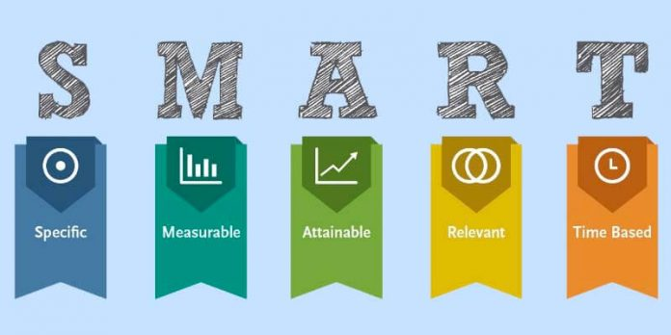

- Specific
  - Well defined
  - Clear to anyone that has a basic knowledge of the project
- Measurable
  - Know if the goal is obtainable and how far away completion is
  - Find out when you have achieved your goal
- Achievable
  - Make sure the goal is achievable.
    - If the goal is set at a level that is too easy, then there is nothing to strive towards.
    - If the goal is too difficult, then it is likely to lead to disappointment if the goal is not achieved.
    - It is best to predict the target you can achieve in a week with hard work and determination.
- Realistic
  - Within the availability of resources, knowledge and time
- Time-Based
  - Enough time to achieve the goal, but not too much time

Activity

Specific Goal for ____________________________________
What exactly do you want to do?
I want to
_____________________________________________________________________

____________________________________________________________________________

Achievable
What do you need in order to make this goal happen?
I need
___________________________________________________________________
___________________________________________________________________________________________________________________________________________________________________________________________________________________________________________________________________________________________________________________________________________________________________________________________________________________________________________________________________________________________________________________________________________________________________________________________________________________________

Measurable
How will you know that you have met your goal?
I will know because
___________________________________________
___________________________________________
___________________________________________

Timely
When will you achieve your goal?
By ______________________________________________

Relevant
Why is this goal important to you?
This is important because
___________________________________________
___________________________________________
___________________________________________

